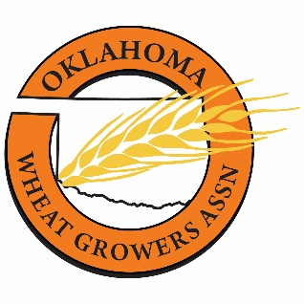
PRODUCERS MEETING

Tuesday, April 23, 2024

Cimarron Electric Cooperative
19306 US-81
Kingfisher, OK
12:00 p.m. – 3:30 p.m.

12:00 p.m. Registration and Luncheon sponsored by Interbank

12:30 p.m Congressman Frank Lucas

1:00 p.m. Why You Need OWGA & Why OWGA Needs You!
Dennis Schoenhals, OWGA President
Jeffrey Hickman, OWGA Executive Director

1:15 p.m. Legislative Update
Jeffrey Hickman, OWGA Executive Director

1:30 p.m. Electrical Safety for the Ag Industry
Justin Glazier, Director of Safety & Compliance, Cimarron Electric Coop

2:30 p.m. Italian Ryegrass Control in Oklahoma Wheat Fields
Dr. Liberty Galvin, Extension Weed Scientist, Oklahoma State University
(One ODAFF CEU in Ag Plant, Demo & Research, Private Applicator)

3:30 p.m. Closing Remarks/CEU sign-in

